**OUTPUT**

Case 1: a = 1 and fruit = "Mango"

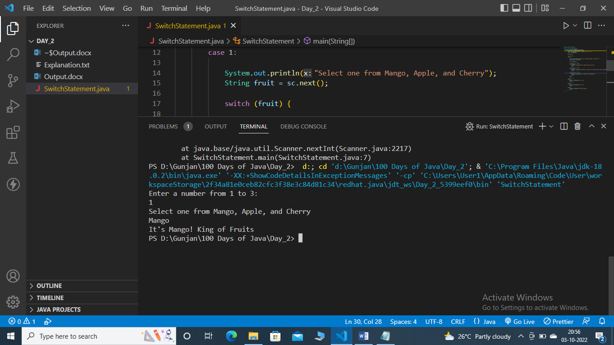

Case 2: a = 1 and fruit = "Apple"

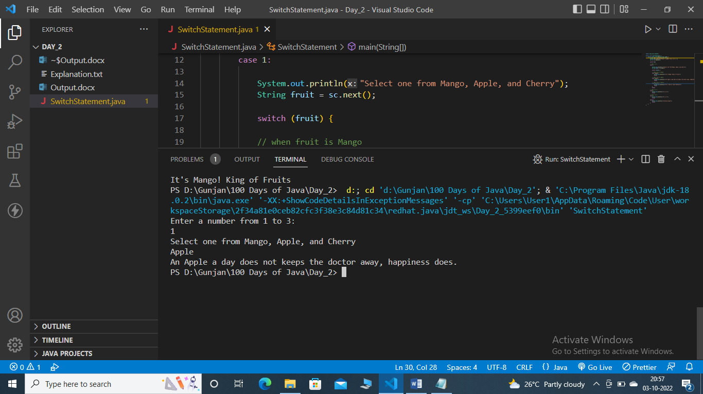

Case 3: a = 1 and fruit = "Cherry"

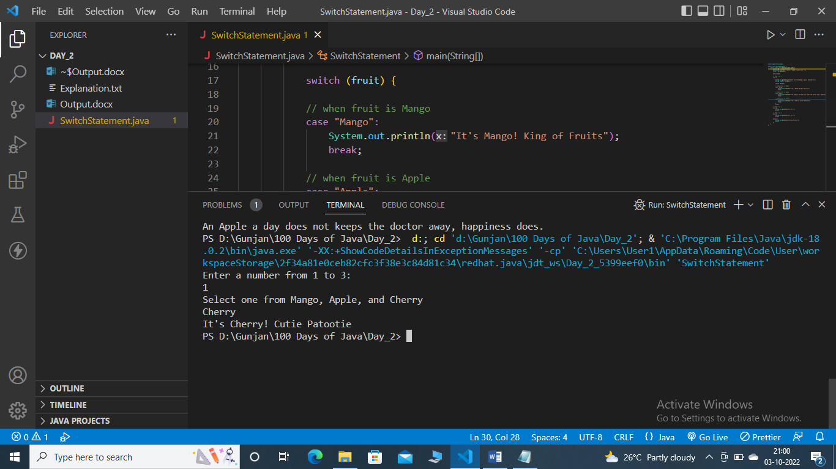

Case 4: a = 2

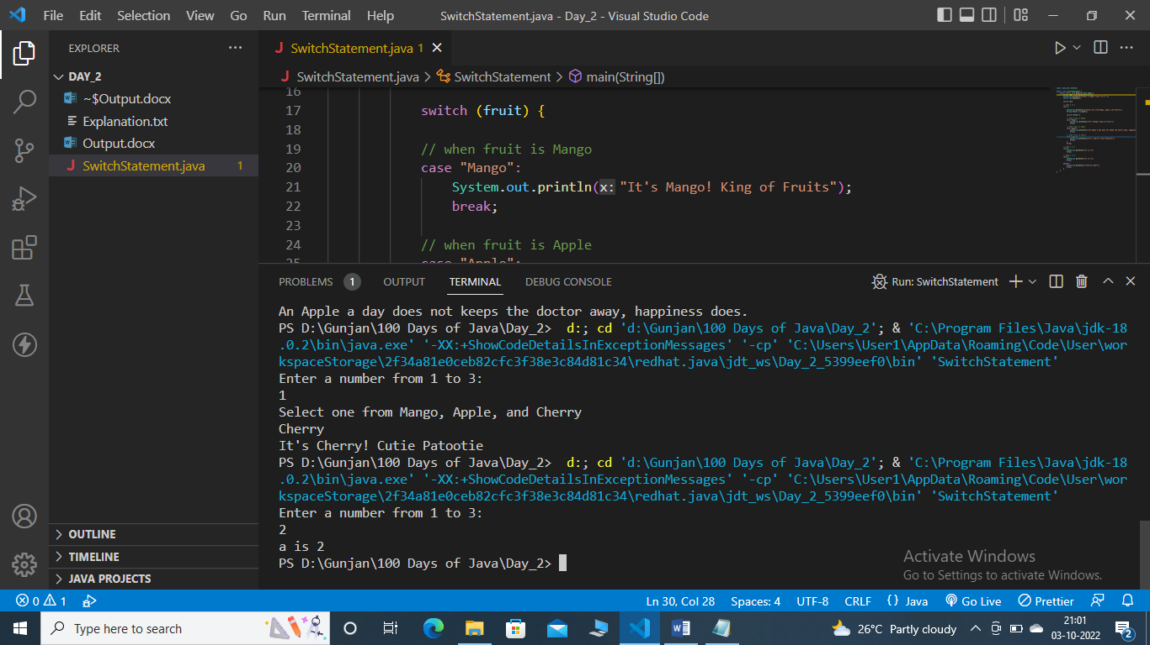

Case 5: a = 3

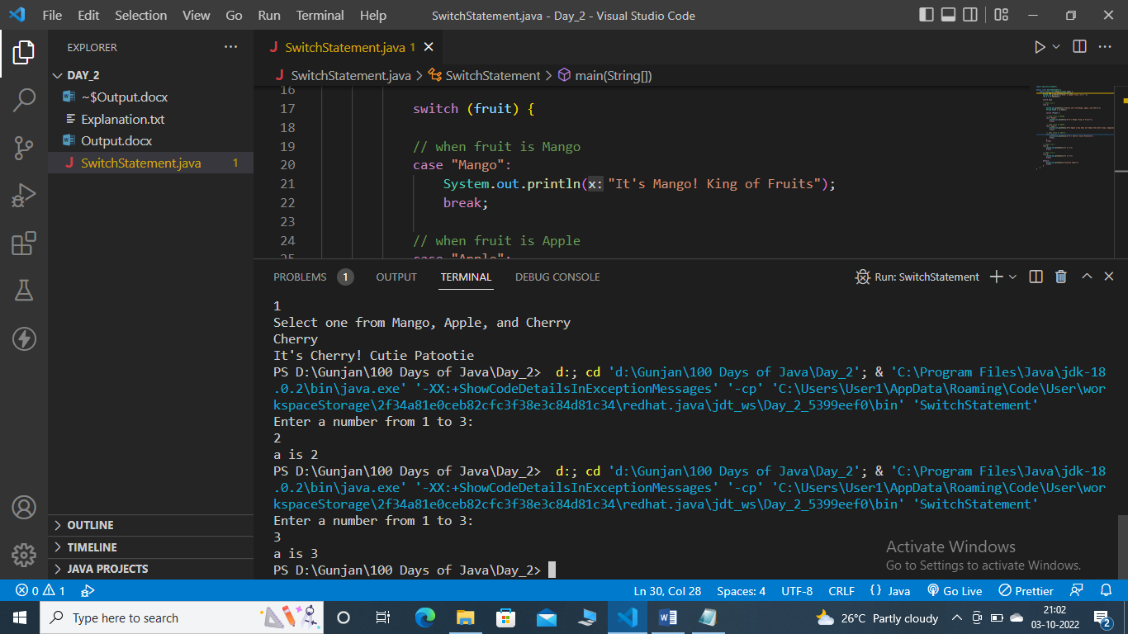

Case 6: a = 4

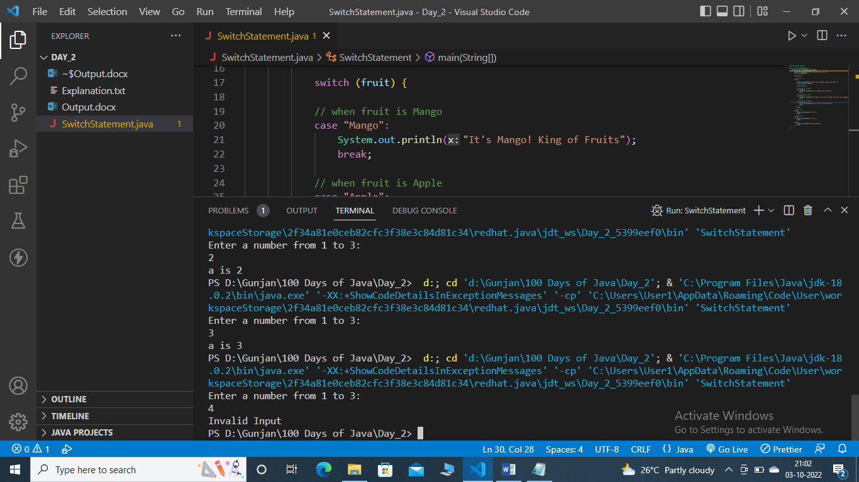

Case 7: a = A

